**Web Programming**

**(LAB Session-07)**

**Working with JavaScript and DOM1.**

**Create an HTML page with a text and five buttons on the screen as shown below.**

1. **Initial background colour of webpage is white.**
2. **When user clicks on a button, the background colour of the webpage should be changed to that colour.**
3. **The text and the colour of the text in the page also changes accordingly as shown in example.**
4. **If user clicks on reset button, the background colour again changes to white. (Note: Below wireframes are just for reference, actual UI of webpage can differ as per the implementation.)**

**Output:**

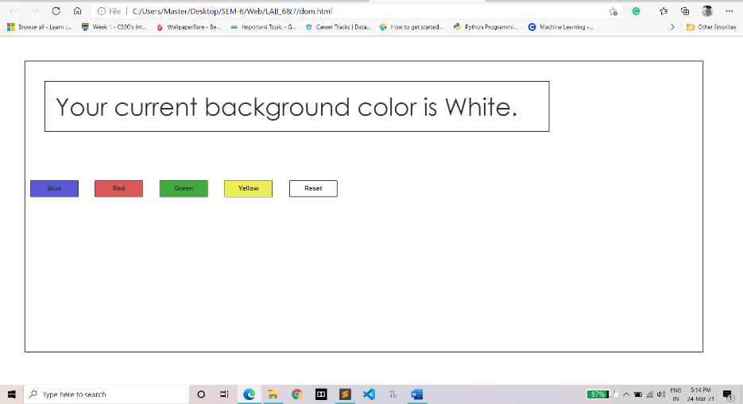

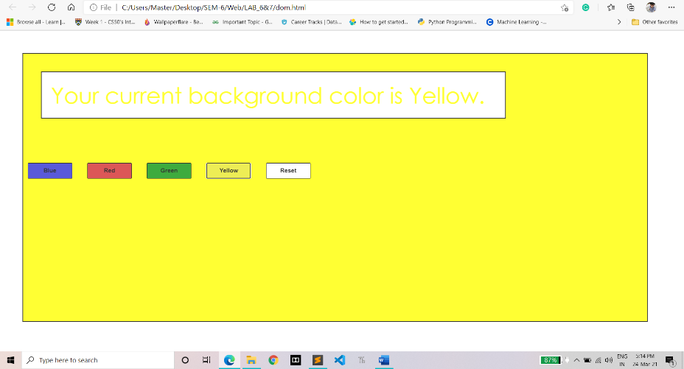

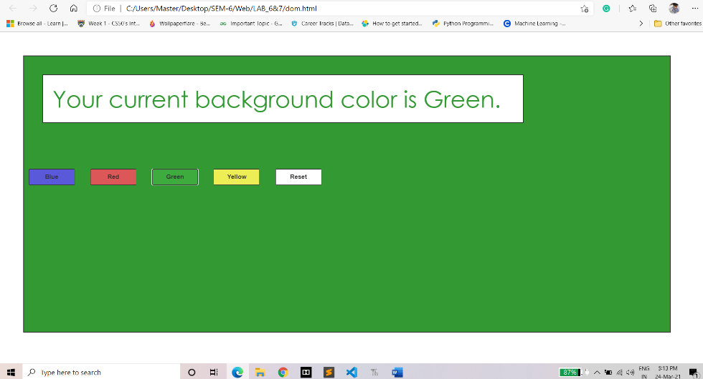

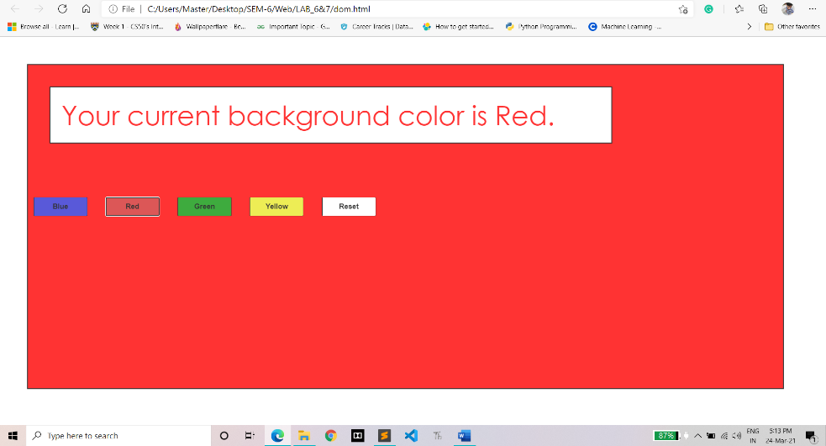

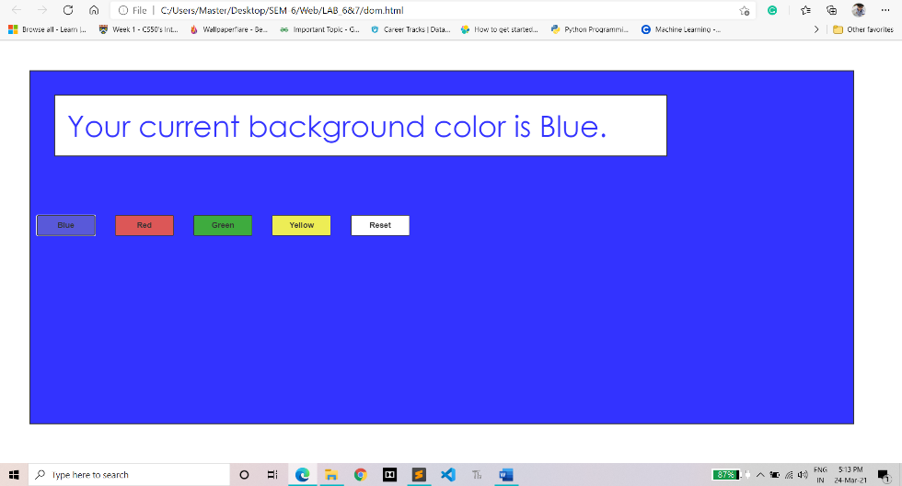

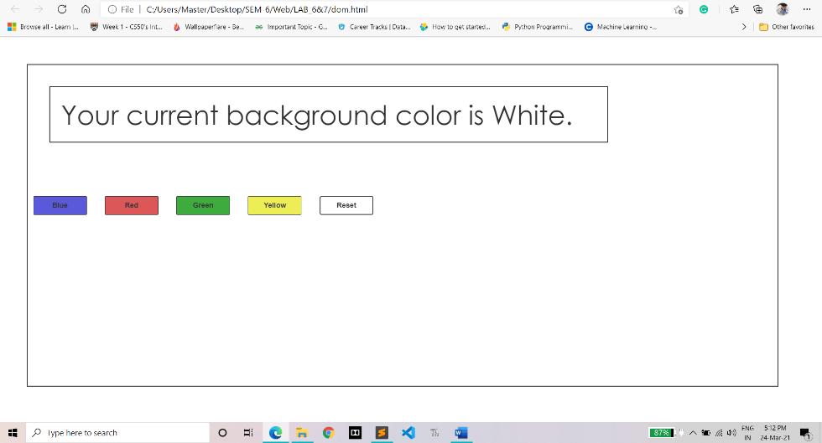

**CODE:**

**<!DOCTYPE html>**

**<html lang="en">**

**<head>**

**<title>Colour Button</title>**

**<style>**

**body {**

**margin: 0;**

**padding: 0;**

**font-size: 50px;**

**font-family: 'Century Gothic';**

**opacity: 80%**

**}**

**#container {**

**width: 1400px;**

**height: 600px;**

**margin: 50px;**

**border: 2px solid #000000;**

**}**

**#text {**

**width: 1000px;**

**height: 35x;**

**margin: 40px;**

**padding: 20px;**

**border: 2px solid #000000;**

**}**

**.btn button {**

**width: 100px;**

**height: 35px;**

**margin: 60px 10px;**

**font-weight: bold;**

**border: 1px solid #000000;**

**}**

**</style>**

**</head>**

**<body>**

**<div id="container">**

**<div id="text">Your current background color is White</div>**

**<div class="btn">**

**<button id="Blue" style="background-color: #3030cf; " onclick="buttonClick('Blue')">Blue</button>**

**<button id="Red" style="background-color: #d32d2d;" onclick="buttonClick('Red')">Red</button>**

**<button id="Green" style="background-color: #0e960e;" onclick="buttonClick('Green')">Green</button>**

**<button id="Yellow" style="background-color: #e9e92a;" onclick="buttonClick('Yellow')">Yellow</button>**

**<button id="Reset" style="background-color: #ffffff;" onclick="buttonClick('White')">Reset</button>**

**</div>**

**</div>**

**<script>**

**function buttonClick(color) {**

**document.getElementById('container').style.backgroundColor = color;**

**document.getElementById('text').innerHTML = "Your current background color is " + color + ".";**

**document.getElementById('text').style.backgroundColor = "White";**

**if (color == 'White') {**

**document.getElementById('text').style.color = "Black";**

**} else**

**{**

**document.getElementById('text').style.color = color;**

**}**

**}**

**</script>**

**</body>**

**</html>**